Supplementary Information

Supplementary Table 1. Processing Parameters

Category | Descriptor No. | Descriptor Name | Description
Processing Parameters | 1 | Calcination temperature | Temperature used during calcination
Processing Parameters | 2 | Calcination time | Duration of calcinations
Processing Parameters | 3 | Sintering temperature | Final sintering temperature
Processing Parameters | 4 | Sintering time | Duration of sintering
Processing Parameters | 5 | Heating rate | Rate of temperature increase
Processing Parameters | 6 | Cooling rate | Rate of cooling after sintering
Processing Parameters | 7 | Milling time | Duration of mechanical milling
Processing Parameters | 8 | Ball-to-powder ratio | Ratio used during milling
Processing Parameters | 9 | Compaction pressure | Ratio used during milling
Processing Parameters | 10 | Annealing temperature | Post-sintering annealing temperature

Supplementary Table 2. Structural parameters
Category | Descriptor No. | Descriptor Name | Description
Structural parameters | 1 | Lattice parameter a | Unit cell parameter a
Structural parameters | 2 | Lattice parameter b | Unit cell parameter b
Structural parameters | 3 | Lattice parameter c | Unit cell parameter c
Structural parameters | 4 | Unit cell volume | Calculated unit cell volume
Structural parameters | 5 | Crystallite size | Average crystallite size (Scherrer method)
Structural parameters | 6 | Lattice strain | Microstrain from W-H analysis
Structural parameters | 7 | Peak intensity (XRD) | Maximum XRD peak intensity
Structural parameters | 8 | Peak position | Diffraction peak position
Structural parameters | 9 | Full width at half maximum (FWHM) | Peak broadening parameter
Structural parameters | 10 | Phase purity index | Fraction of orthorhombic phase

Supplementary Table 3. DielectricProperties

Category | Descriptor No. | Descriptor Name | Description
Dielectric Properties | 1 | Dielectric constant (1 kHz) | εr measured at 1 kHz
Dielectric Properties | 2 | Dielectric constant (10 kHz) | εr measured at 10 kHz
Dielectric Properties | 3 | Dielectric constant (100 kHz) | εr measured at 100 kHz
Dielectric Properties | 4 | Dielectric constant (1 MHz) | εr measured at 1 MHz
Dielectric Properties | 5 | Dielectric loss (1 kHz) | tanδ measured at 1 kHz
Dielectric Properties | 6 | Dielectric loss (10 kHz) | tanδ measured at 10 kHz
Dielectric Properties | 7 | Dielectric loss (100 kHz) | tanδ measured at 100 kHz
Dielectric Properties | 8 | Dielectric loss (1 MHz) | tanδ measured at 1 MHz
Dielectric Properties | 9 | Dielectric relaxation frequency | Frequency of relaxation peak
Dielectric Properties | 10 | Polarization factor | Derived polarization parameter

Supplementary Table 4. Ferroelectric Properties

Category | Descriptor No. | Descriptor Name | Description
Ferroelectric Properties | 1 | Remnant polarization (Pr) | Residual polarization
Ferroelectric Properties | 2 | Saturation polarization (Ps) | Maximum polarization
Ferroelectric Properties | 3 | Coercive field (Ec) | Field required to switch polarization
Ferroelectric Properties | 4 | Hysteresis loop area | Area enclosed in P–E loop
Ferroelectric Properties | 5 | Switching energy | Energy required for polarization switching
Ferroelectric Properties | 6 | Polarization asymmetry | Asymmetry in hysteresis loop
Ferroelectric Properties | 7 | Domain switching rate | Rate of domain reversal
Ferroelectric Properties | 8 | Polarization stability | Stability under electric field cycling
Ferroelectric Properties | 9 | Leakage current density | Electrical leakage behavior
Ferroelectric Properties | 10 | Ferroelectric coupling coefficient | Coupling strength parameter

Supplementary Table 5. Derived/Engineered Features

Category | Descriptor No. | Descriptor Name | Description
Derived/Engineered Features | 1 | Grain size / crystallite size ratio | Microstructural relationship
Derived/Engineered Features | 2 | Lattice distortion index | Structural distortion parameter
Derived/Engineered Features | 3 | Strain–polarization coupling | Interaction parameter
Derived/Engineered Features | 4 | Density–dielectric correlation | Derived correlation metric
Derived/Engineered Features | 5 | Temperature gradient factor | Processing temperature variation
Derived/Engineered Features | 6 | Dielectric dispersion factor | Frequency dispersion metric
Derived/Engineered Features | 7 | Ferroelectric switching index | Switching behavior indicator
Derived/Engineered Features | 8 | Structure–property coupling coefficient | Correlation descriptor
Derived/Engineered Features | 9 | Composite feature index | Combined engineered feature

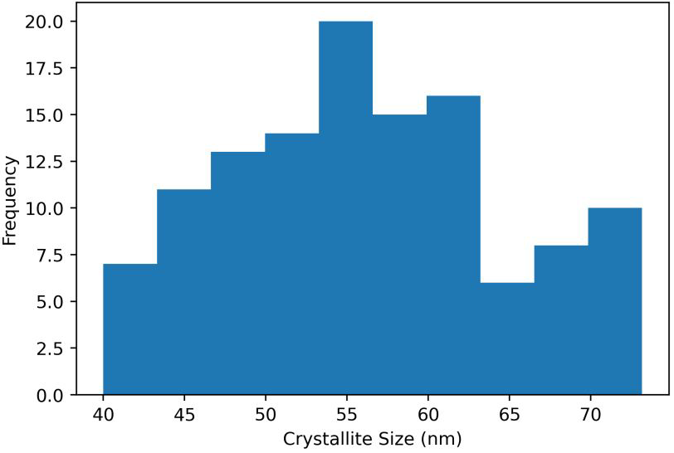
Supplementary Fig. 1. Distribution of crystallite size in the dataset

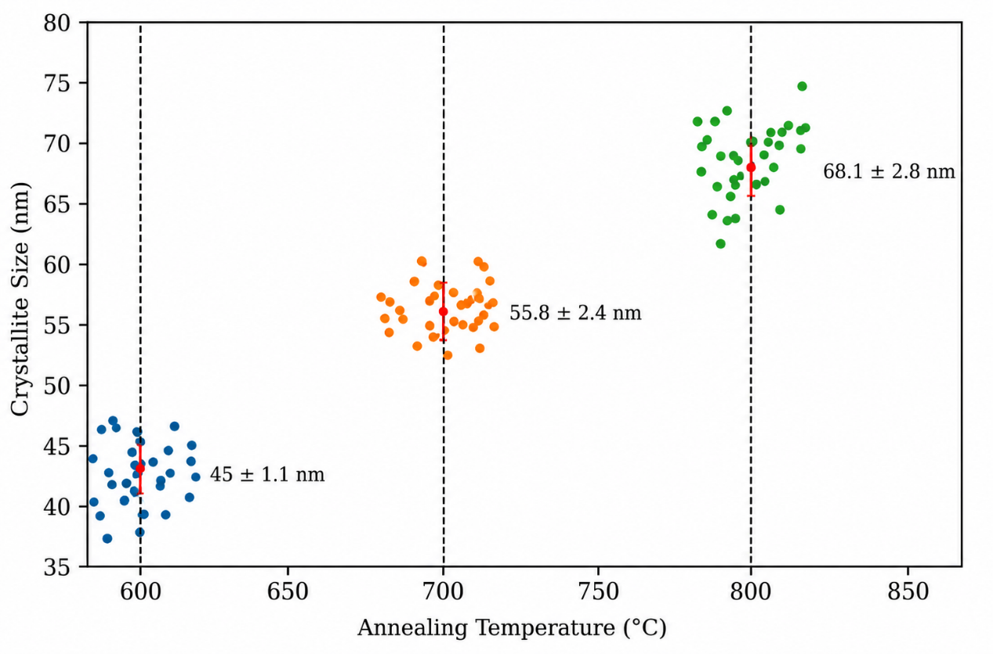
Supplementary Fig. 2. Variation of crystallite size with sintering temperature for CaTiO₃ nano-ceramics, indicating the effect of thermal processing on structural evolution.
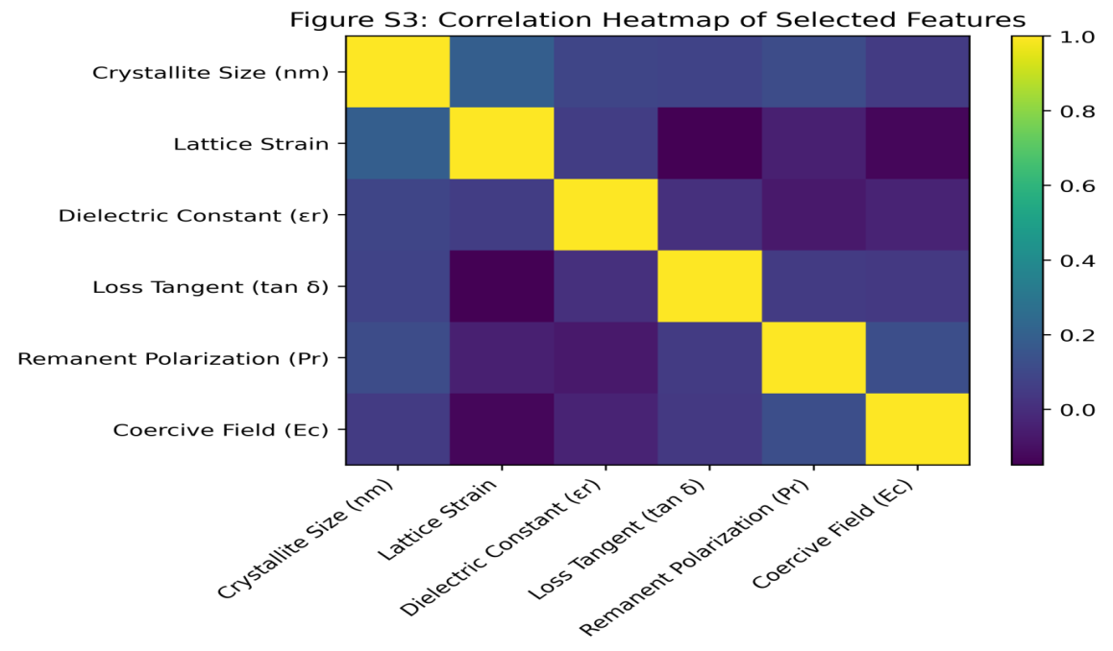
Supplementary Fig. 3: Correlation heatmap illustrating the relationships among structural, dielectric, and ferroelectric parameters of CaTiO₃ nano-ceramics, including crystallite size, lattice strain, dielectric constant (ε_{r}), loss tangent (tan δ), remanent polarization (P_{r}), and coercive field (E_{c}).

